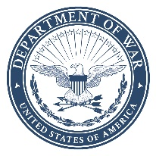 | DEPARTMENT OF THE AIR FORCE  333RD WING  PODUNK AIR FORCE BASE ARKANSAS
20 April 2025

MEMORANDUM FOR AFPC/DPSIMF
MAJCOM/A1 VOTING ASSISTANCE OFFICER

FROM: 333 WG/CC
550 C Street West, Suite 37 Podunk AFB, AR 58150-4737

SUBJECT: Installation Voting Assistance Officer Appointment

- The following individuals have been appointed as Installation Voting Assistance Officer (IVAO) and Alternate IVAO IAW AFI 36-3107, paragraph 4.7.1. Both IVAOs are appointed for a period of no less than two years, through the next general election cycle.

IVAO | ALTERNATE
Rank, Name, Email, DSN | Rank, Name, Email, DSN
Major John Doe, john.doe@podunk.af.mil  DSN 979-9999 | Major Jane Doe, jane.doe@podunk.af.mil  DSN 979-8888
- I have considered the ops tempo, availability, and deployment schedule of these two individuals in my decision making

- If you have any questions, please contact me at DSN 979-7448 or via email at i.m.sample@podunk.af.mil.

I.M. Sample, General, USAF
Commander

